**Group Workshop**

Week 3 [b], Semester 1: Code Storage and Versioning with Git

**Why store and version your code**

Storing and versioning your code keeps your progress safe and flexible. You can return to a working state when an experiment goes wrong, capture meaningful milestones as a project evolves, collaborate without overwriting each other and move between computers without juggling loose or zipped files.

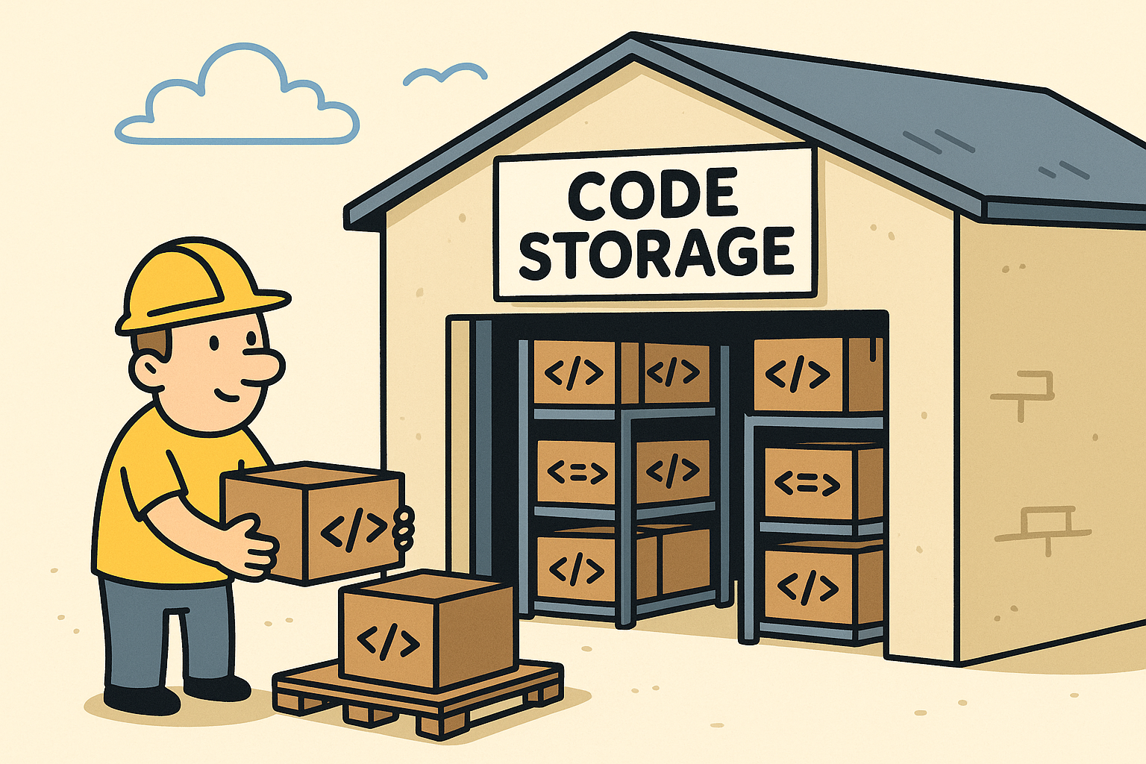

Figure An Illustration of Code Storage and Versioning

In this exercise you will use Git to store and manage versions of your projects so you can work with confidence and keep a reliable record of changes.

**Git**

Git is a distributed version control software system that enables you to manage different versions of your code or data. It is often used to control source code by programmers who are developing software. However, it is also used by artists and others to store and version their code and data, including to work collaboratively in a team.

**Technologies for storing and versioning code**

There are several version control systems in common use. They are defined as follows:

* Git - a distributed version control system that records snapshots (commits), supports branching and merging and works offline.
* Mercurial (hg) - a distributed version control system with a streamlined command set and similar concepts to Git.
* Subversion (SVN) - a centralized version control system where history lives on a central server and clients commit to it.

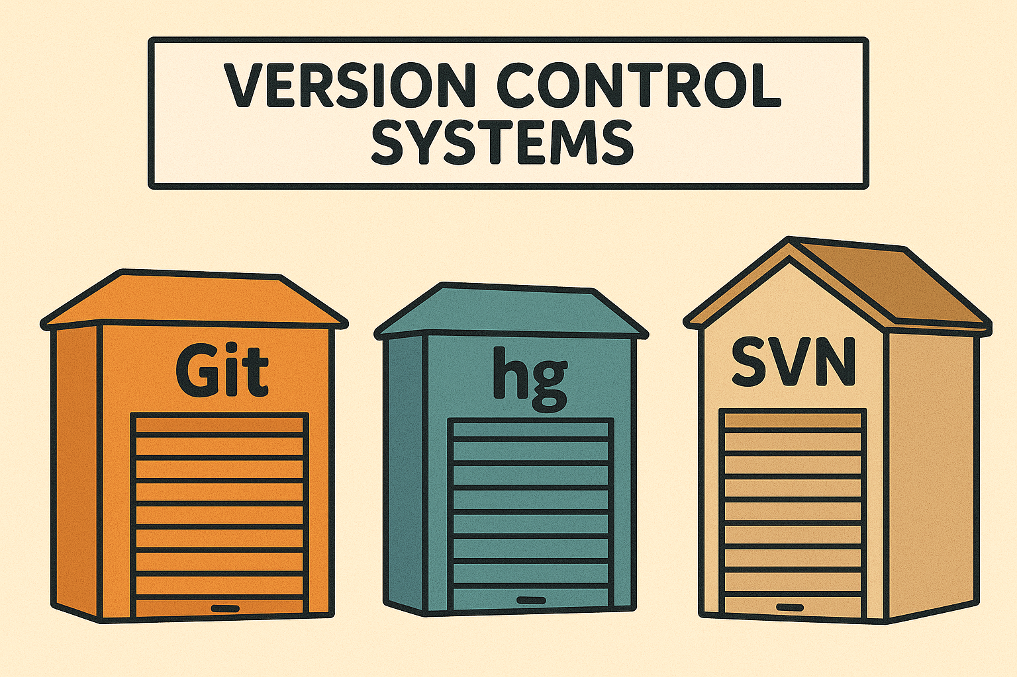

Figure Git, Mercurial (hg) and Subversion (SVN) are three types of versional control systems

In this tutorial we will use Git. It is widely available, integrates with [GitHub](https://github.com/) and [Gitee](https://gitee.com/), and makes local commits fast and reliable. The ideas generalize to other systems, but the commands differ.

**How it works**

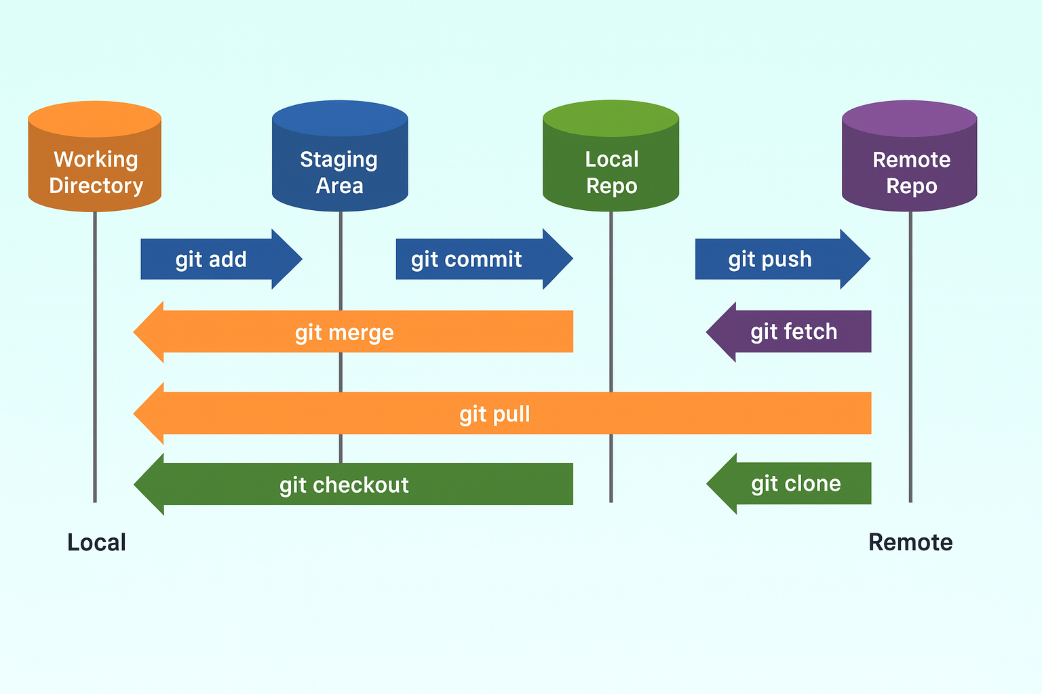

Figure 3 An overview of how Git works

A repository (repo) is a project folder tracked by Git. A commit is a snapshot with a short message describing what changed. A branch is a safe lane to try ideas without affecting the main line of work, and a merge brings work from one branch into another. A remote is the online copy on a service like GitHub or Gitee. In practice you edit files, stage them with add, make a commit, push to the remote and others can pull those changes.

**Choose your platform**

Host your Git repository at <https://github.com>. If you cannot use GitHub, then use Gitee at <https://gitee.com> as an alternative. Follow the tutorial below for the platform that you choose.

**Tutorial A - GitHub**

1. Create an account and repository

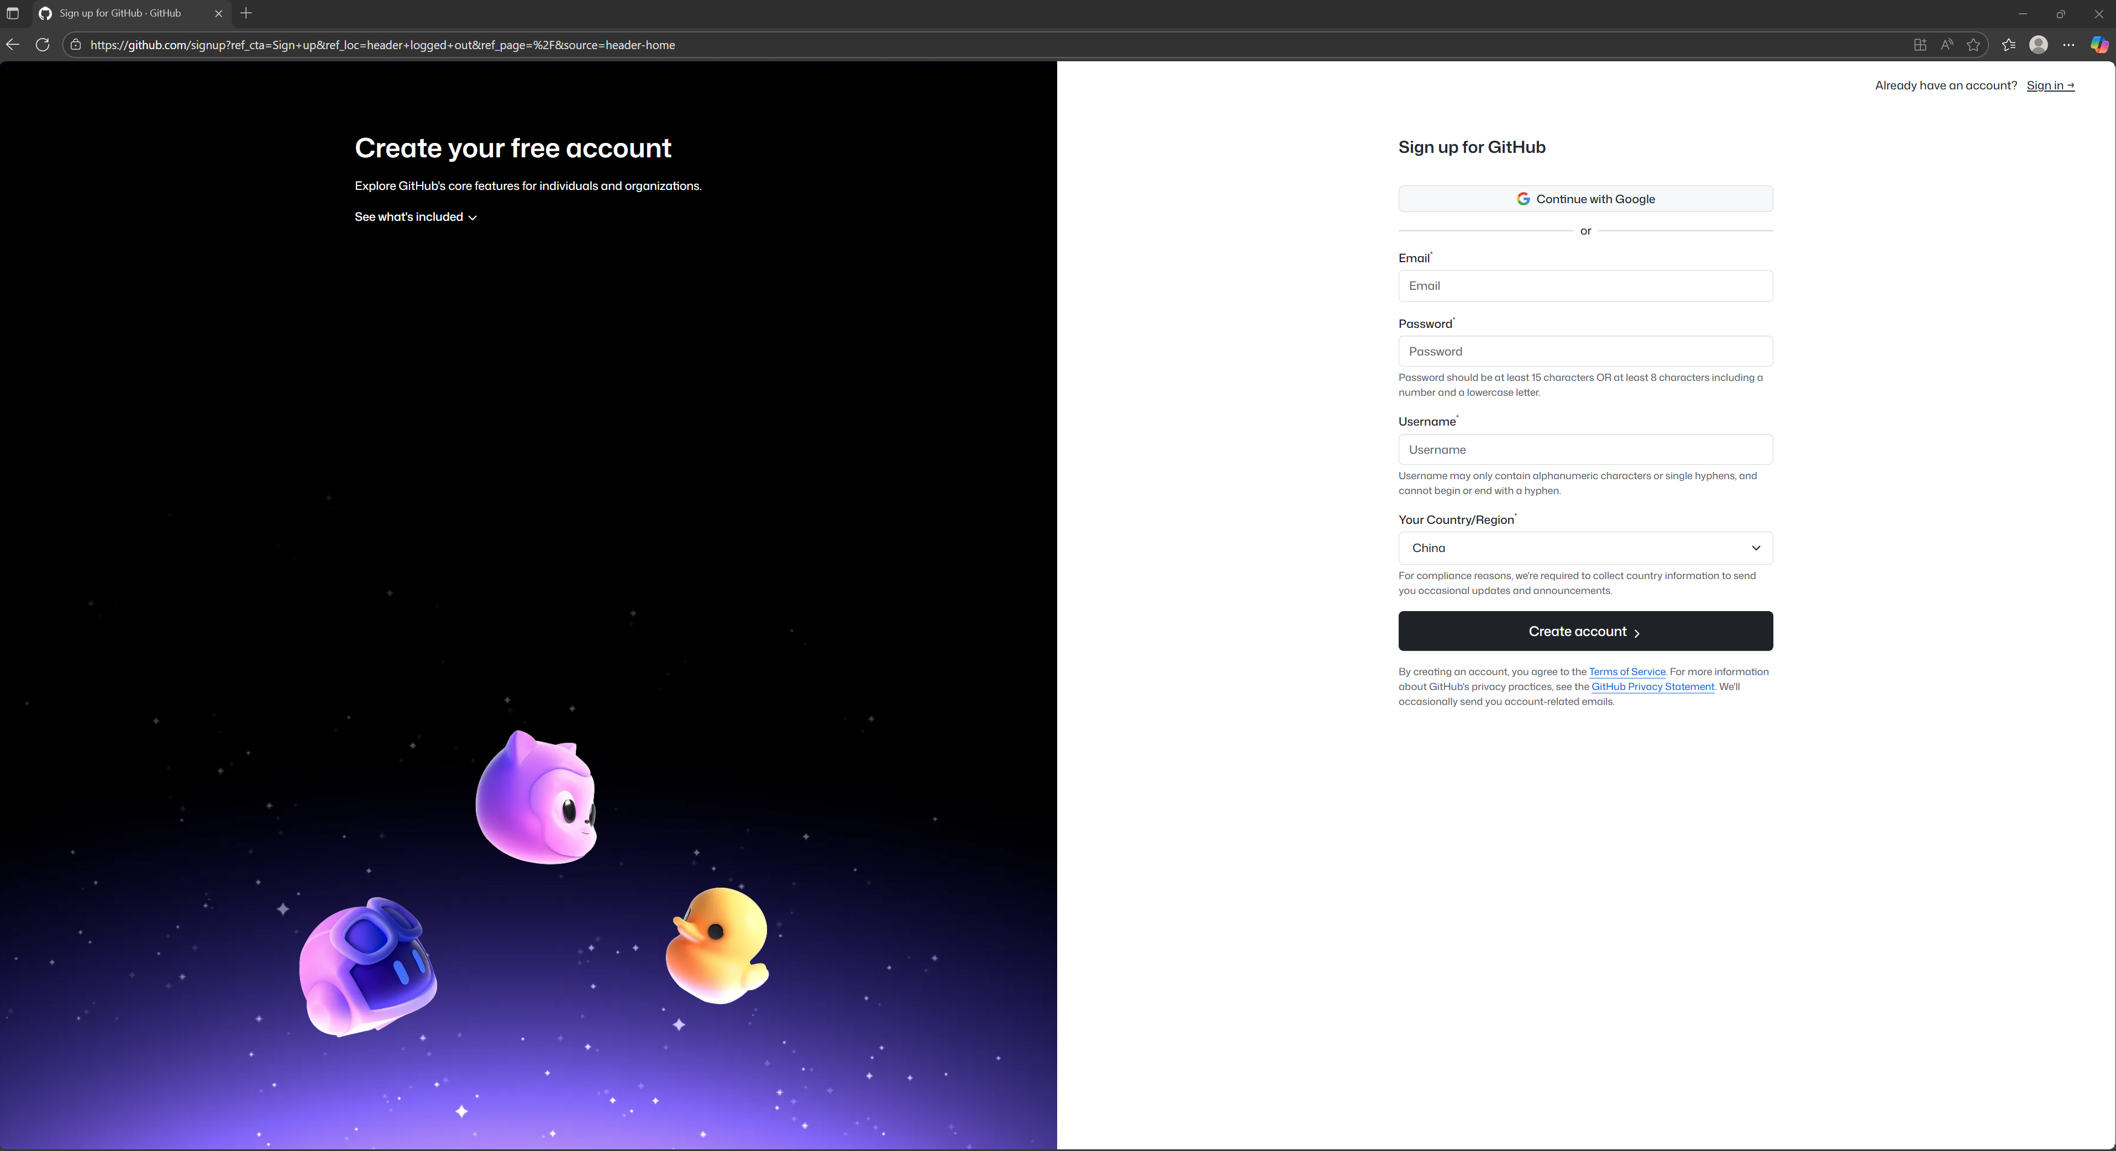

Figure 4 GitHub sign-up page

Open <https://github.com> and [sign up](https://github.com/signup) if you do not already have an account (otherwise, [sign in](https://github.com/login) if you already do). Create a new repository by selecting New, entering a name for your project and confirming to create the repository. The repository page provides a remote URL, which you will use to connect your local project to GitHub in the next steps.

2. Install and configure Git

Download Git for Windows from <https://github.com/git-for-windows/git/releases/download/v2.51.0.windows.1/Git-2.51.0-64-bit.exe> and install it (Mac should already have it installed by default).

3. Open your project folder

Open your project folder in the Windows Terminal

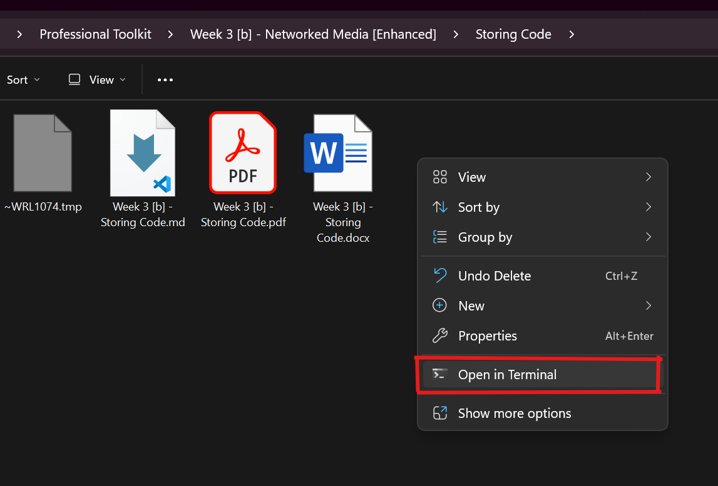

Figure 5 How to open your project in the Windows Terminal (Right-Click in your project folder and choose Open in Terminal)

Continue by running the following commands with your own information replacing what is in the quotes.

git config --global user.name "Your Name"

git config --global user.email "you@example.com"

4. Initialize the repo locally and push the first version

You are about to turn the current folder into a Git repository, save a first snapshot, connect it to your GitHub repository and upload that snapshot. This establishes the link so future commits can be pushed easily.

Initialize Git in this folder

git init

Optionally add a .gitignore file first (See section 6)

Save your current project as the first commit

git add .

git commit -m "Initial commit"

Connect to your GitHub repo (replace USERNAME/REPO)

git branch -M main

git remote add origin https://github.com/USERNAME/REPO.git

Push your versioned code to GitHub

git push -u origin main

5. Daily versioning routine

Each time you finish a meaningful change, create a commit and push it. Commits are your named versions; pushing stores them on GitHub.

Stage and commit meaningful changes

git add .

git commit -m "Describe what changed"

Publish your new version

git push

Optional - SSH (avoid password prompts after setup)

ssh-keygen -t ed25519 -C "you@example.com"

Copy `%USERPROFILE%\.ssh\id_ed25519.pub` to GitHub under Settings, SSH and GPG keys, then add a new SSH key. Switch the remote with: `git remote set-url origin [git@github.com:USERNAME/REPO.git`](mailto:git@github.com:USERNAME/REPO.git%60).

6. Create a minimal .gitignore file

Some files don’t need to be committed to your project’s history. Typical examples are generated build output, caches, logs, editor/OS settings, machine‑local configuration and private files such as passwords or API keys.

We create and use a `.gitignore` file to tell Git to skip these files, so that your history stays clean and the repository stays small.

Make a file named `.gitignore` in your project folder and add lines like these:

Build/temp

node_modules/

build/

.dist/

.vscode/

.DS_Store

Thumbs.db

*.log

7. Large files (optional Git LFS)

If you must version large files such as .mp4, .mov or .psd, then use Git Large File Storage (Git LFS), which is an open-source Git extension designed to handle large files efficiently within Git repositories. To install and use it, do the following:

git lfs install

In your repo, track needed types

git lfs track "*.mp4"

git lfs track "*.mov"

git lfs track "*.psd"

Commit the LFS config

git add .gitattributes

git commit -m "chore: enable LFS for media"

Free plans often limit LFS storage and bandwidth.

8. What you should be able to do now

You should have a repository on GitHub or Gitee, a local repository initialized with Git, an initial commit pushed online, and the ability to make a change, commit it and push a new version. If needed, you can also set up SSH for easier authentication and Git LFS for large files.

**Tutorial B - Gitee**

1. Create an account and repository

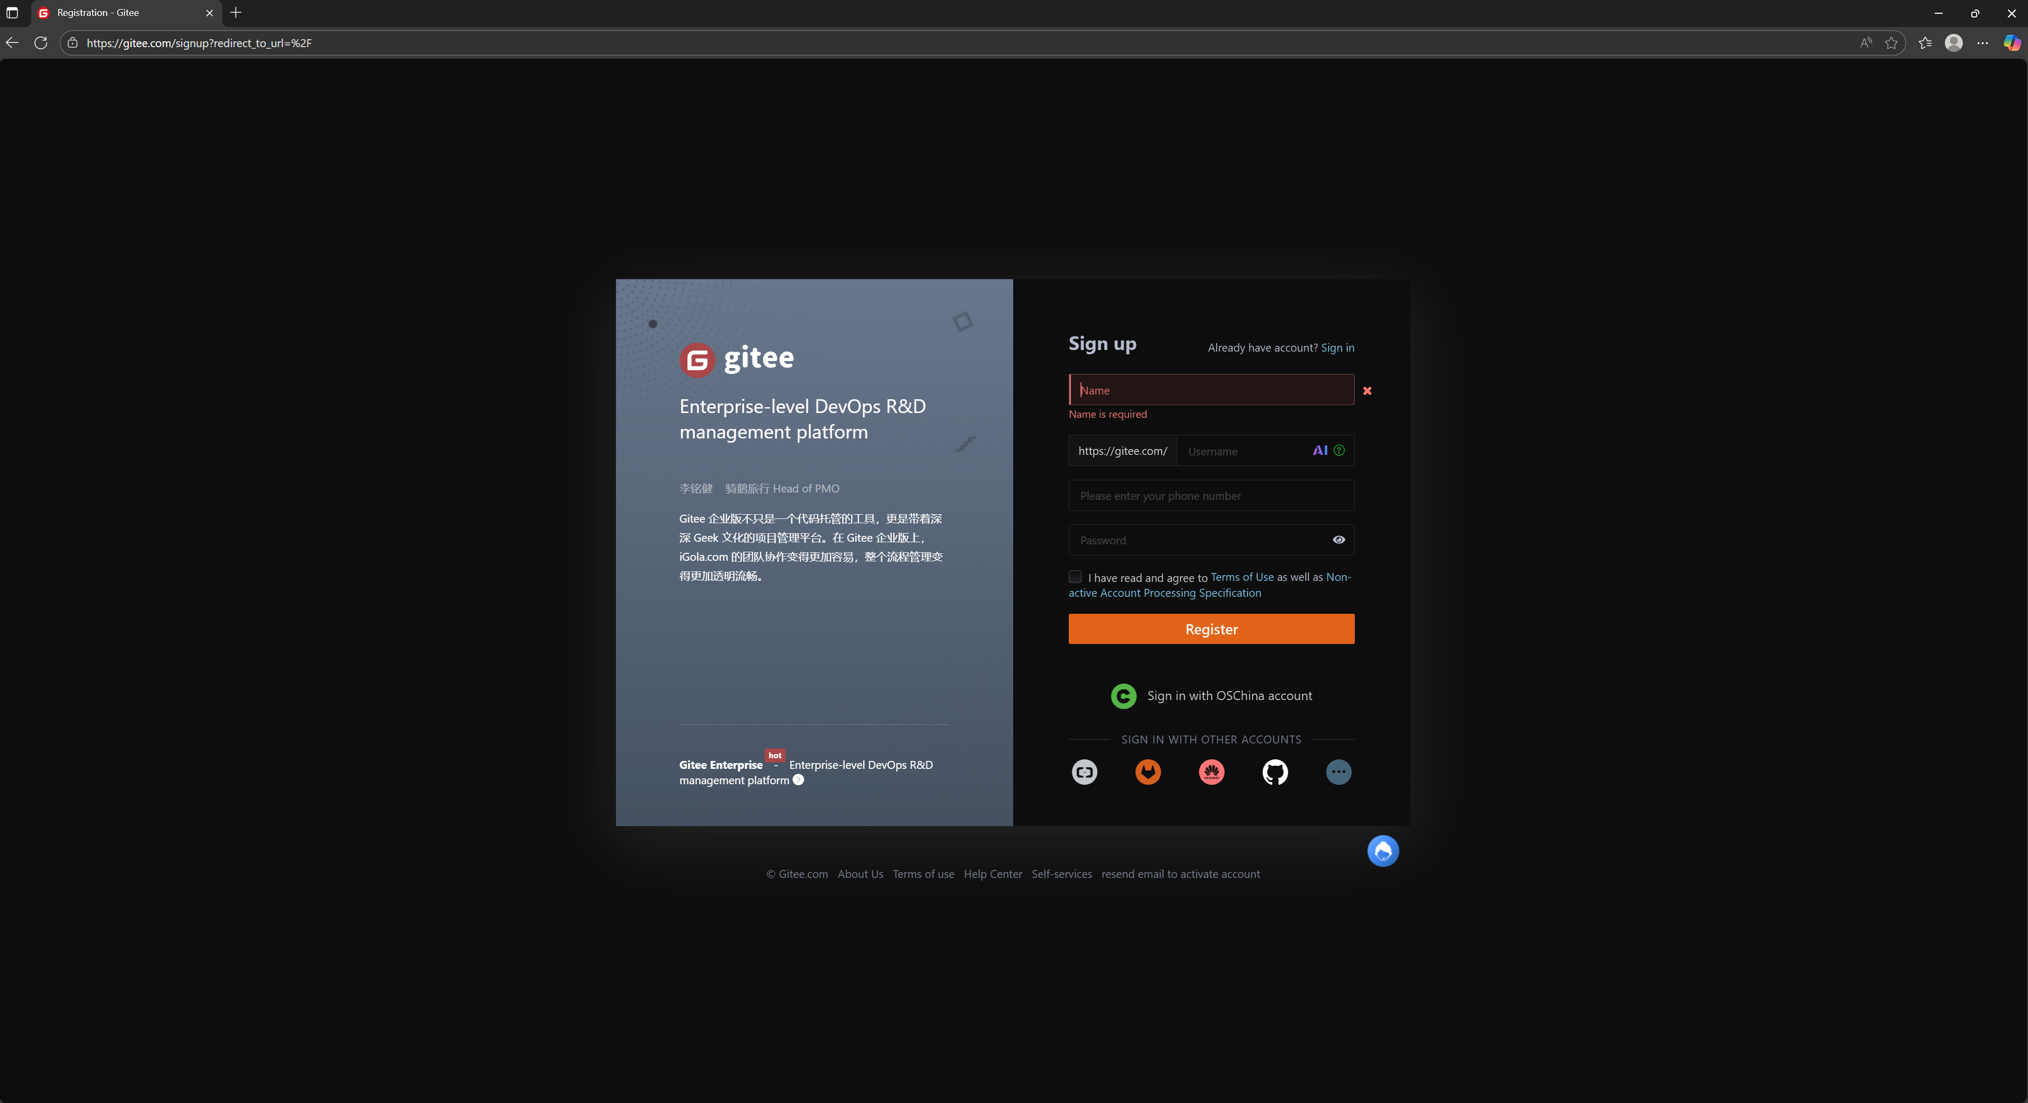

Figure 6 Gitee sign-up page

Open <https://gitee.com/signup> to create an account if needed. Use the plus menu to create a repository, give it a name and create it. The repository page shows a remote URL; which you will connect to from your local project shortly.

2. Install and configure Git

Download Git for Windows from <https://github.com/git-for-windows/git/releases/download/v2.51.0.windows.1/Git-2.51.0-64-bit.exe> and install it (Mac should already have it installed by default).

3. Open your project folder

Open your project folder in the Windows Terminal



Figure 7 How to open your project in the Windows Terminal (Right-Click in your project folder and choose Open in Terminal)

Continue by running the following commands with your own information replacing what is in the quotes.

git config --global user.name "Your Name"

git config --global user.email "you@example.com"

4. Initialize the repo locally and push the first version

These commands initialize Git in your folder, save a first commit, connect to your Gitee repository, and upload that commit so it’s stored online.

git init

git add .

git commit -m "Initial commit"

git branch -M main

git remote add origin https://gitee.com/USERNAME/REPO.git

git push -u origin main

5. Daily versioning routine

After meaningful changes, commit and push to save the new version online.

git add .

git commit -m "Describe what changed"

git push

Optional - SSH on Gitee

ssh-keygen -t ed25519 -C "you@example.com"

Add `%USERPROFILE%\.ssh\id_ed25519.pub` in Gitee under Settings, SSH Public Keys, then add. Switch the remote with: `git remote set-url origin git@gitee.com:USERNAME/REPO.git`.

6. Create a minimal .gitignore file

Some files don’t need to be committed to your project’s history. Typical examples are generated build output, caches, logs, editor/OS settings, machine‑local configuration and private files such as passwords or API keys.

We create and use a `.gitignore` file to tell Git to skip these files, so that your history stays clean and the repository stays small.

Make a file named `.gitignore` in your project folder and add lines like these:

Build/temp

node_modules/

build/

.dist/

.vscode/

.DS_Store

Thumbs.db

*.log

7. Large files (optional Git LFS)

If you must version large files such as .mp4, .mov or .psd, then use Git Large File Storage (Git LFS), which is an open-source Git extension designed to handle large files efficiently within Git repositories. To install and use it, do the following:

git lfs install

In your repo, track needed types

git lfs track "*.mp4"

git lfs track "*.mov"

git lfs track "*.psd"

Commit the LFS config

git add .gitattributes

git commit -m "chore: enable LFS for media"

Free plans often limit LFS storage and bandwidth.

8. What you should be able to do now

You should have a repository on GitHub or Gitee, a local repository initialized with Git, an initial commit pushed online, and the ability to make a change, commit it and push a new version. If needed, you can also set up SSH for easier authentication and Git LFS for large files.

9. Troubleshooting

If something goes wrong while committing or pushing, try the following quick fixes.

Push rejected due to large files

Remove generated/build folders; use Git LFS for required big assets.

Repeated login prompts

Complete browser sign-in when asked or switch to SSH.

Merge conflicts

Open conflicted files, keep the intended lines, remove `<<<<<<<`, `=======`, `>>>>>>>`, then commit.

Windows line endings

git config --global core.autocrlf true` can help normalize line endings.